A short history of Submarines and Submersibles

Exploring the depths of the ocean has fascinated people for thousands of years. Yet it was not on until the mid-twentieth century that exploration of the deepest parts of the ocean were possible.
Alexander the Great: Led by the king of Macedonia (336–323 BCE), the ancient Athenians used divers in secret military operations. Alexander the Great who was a student of the great philosopher Aristotle, was curious to explore the ocean. He had himself lowered into the water in a glass diving bell.
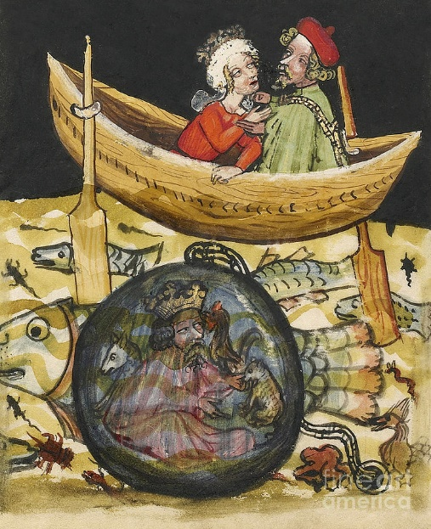
An illustration showing Alexander the Great in a diving bell lowered from a small boat. (Photo by Getty Images)

Many people created new ideas for submersible boat designs over the centuries, but they achieved limited success.
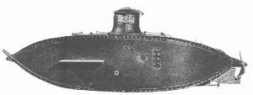
The late 19th and early 20th century:

Holland submarines: John Phillip Holland designed an unarmed
submersible Holland I prototype, which was
launched 22nd May 1878.

Working and improving his designs, John Phillip Holland launched Holland VI May 1897. In April 1900 the US Navy purchased this submarine. It was added to the fleet as USS Holland (SS-1) six months later.

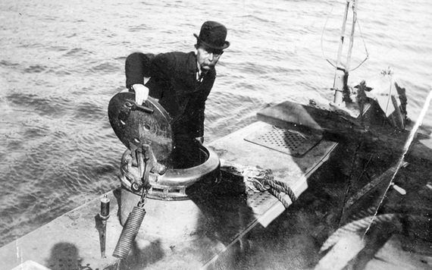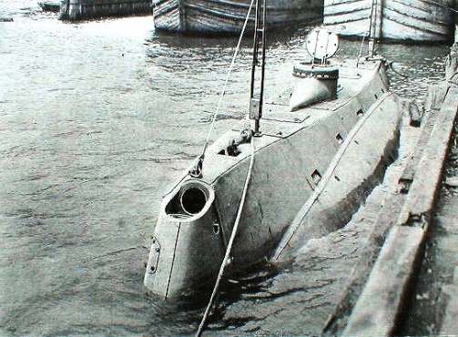

John Phillip Holland introduced a new method of propulsion using a gasoline engine. Designing a small, lightweight gasoline engine it turned a propeller while the boat cruised on the surface. The engine was also designed to run a generator that produced electricity. The was used to charge batteries necessary to run an electric motor during underwater operations.
The Nuclear Powered Submarine:
The designs of Holland’s submarines later reformed warfare for the Americans and Germans – particularly in the 2nd World War with the use of submarines were used to destroy ships at sea.

Despite the success of diesel-powered submarines, the quest to improve the design of the submarine continued. This was partly driven by the need for a single power source. The concept of nuclear power was discovered by German scientists in the 1930's. Upon learning of this idea, American physicist Ross Gunn visualized the potential for nuclear-powered submarines.
The United States developed the world's first nuclear-powered submarine: the Nautilus. Its first nuclear-powered journey took place on Jan. 21, 1954. In contrast to the diesel-electric subs it could stay underwater for great lengths of time because it didn't have to surface to recharge electric batteries.
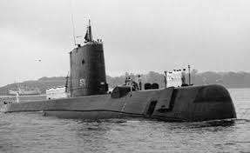
American nuclear submarines are able to spend up to six months on submerged patrol. When the vessel returns to its home base, a complete crew is rotated. As the vessel only needs to refuel once or twice over its lifetime, submarines only need to stop to restock food and supplies.
World War I and World War II: Military submarines first made a significant impact in World War I. The U-boats of Germany saw action in the First Battle of the Atlantic, and were responsible for sinking RMS Lusitania. By the second World War countries including Japan, USA and German used an extensive number of submarines in the battle across the Atlantic ocean and in the Pacific ocean.
Submarines and submersibles have also become important tools for marine research and scientific purposes in many countries around the world. From discovering the deepest parts of the ocean, monitoring oil rigs and pipelines at sea, to searching for ship wrecks, to incredible new discoveries under the ocean.

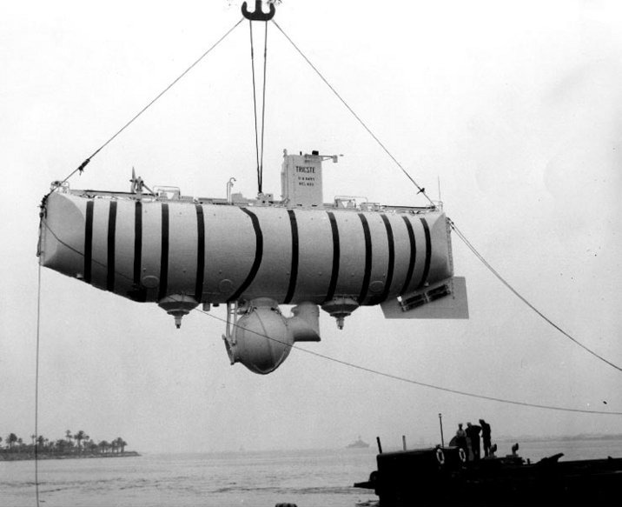
In 1960, the Trieste Bathyscaphe was used by Jacques Piccard and Don Walsh who were the first people to explore the deepest part of the world's ocean, and the deepest location on the surface of the Earth's crust.

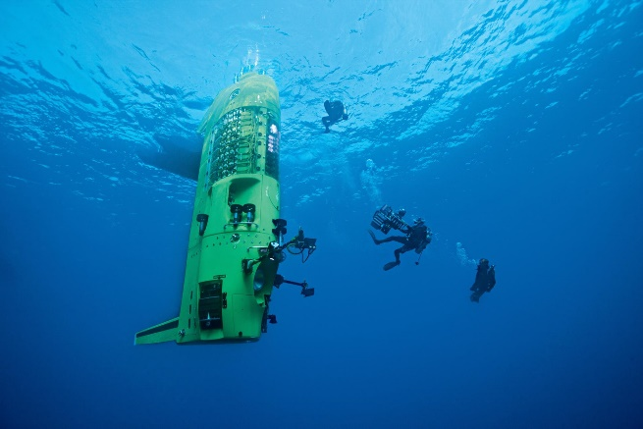
On 26th Mach the Deepsea Challenger deep-diving submersible (DCV 1), was piloted by Canadian film director James Cameron who reached the bottom of the Challenger Deep, in the Mariana Trench the deepest-known point on Earth. The maximum depth recorded during this record-setting dive was 10,908 metres

The Future of Submarines:
Changes in world politics, mapping of the seabed and space technologies are creating new challenges and opportunities for submarines in the 21st century. They continued to be used in military fleets to monitor countries borders at sea. They are also used for research, scientific discoveries, monitoring of oil and gas rigs at sea, salvage of shipwrecks, and even tourism.
In the future, some submarines may not need to have a crew and will be run using computer technology that ‘talks to satellites’. This information can then be transferred to the submarine base on land for analysis.

